CERTIFICATE
I DO HERE BY CERTIFY THAT THIS PROJECT TITLED “WATER CONSERVATION, RAIN WATER HARVESTING, WATER SHED MANGEMENT, ENVIRONMENTAL ETHICS” IS DONE BY
ISHMEET KAUR, KULPREET KOUR AND SHIVANI SISODIA
OF “ SHRI GURU GOBIND SINGH COLLEGE OF COMMERCE”, HAVE BEEN SUBMITTED UNDER THE GUIDANCE OF OUR ENVIRONMENTAL TEACHER “DR. GURVEEN MAAM” .
ACKNOWLEGDEMENT AND BELIEF , THIS PROJECT WORK IS COMPLETED FROM EVERY ASPECTS, WHICH CAN HELP STUDY IN VARIOUS WAYS.

ACKNOWLEDGEMENT
WE WOULD LIKE TO EXPRESS OUR SPECIAL THANKS OF GRATITUDE TO OUR TEACHER “DR. GURVEEN KAUR” AS WELL AS OUR PRINCIPAL “DR. J.B. SINGH” WHO GAVE US THE GOLDEN OPPORTUNITY TO DO THIS WONDERFUL PROJECT ON THE TOPIC “ WATER CONSERVATION, RAIN WATER HARVESTING , WATER SHED MANGEMENT, ENVIRONMENTAL ETHICS” .
I AM REALLY THANKFUL TO THEM.

Water conservation
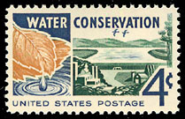
United States postal stamp advocating water conservation.
Water conservation encompasses the policies, strategies and activities to manage fresh water as a sustainable resource, to protect the water environment, and to meet current and future human demand. Population, household size and growth and affluence all affect how much water is used. Factors such as climate change will increase pressures on natural water resources especially inmanufacturing and agricultural irrigation.^{[1]}

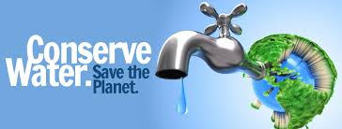

The goals of water conservation efforts include:
To ensure availability for future generations, the withdrawal of fresh water from an ecosystem should not exceed its natural replacement rate.
- Energy conservation. Water pumping, delivery and waste water treatment facilities consume a significant amount of energy. In some regions of the world over 15% of total electricity consumption is devoted to water management.
- Habitat conservation. Minimizing human water use helps to preserve fresh water habitats for local wildlife and migrating waterfowl, as well as reducing the need to build new dams and other water diversion infrastructures.

Contents
- 1 Strategies
- 2 Social solutions
- 3 Household applications
- 4 Commercial applications
- 5 Agricultural applications
- 6 Minimum water network target and design

Strategies
In implementing water conservation principles there are a number of key activities that may be beneficial.
- Any beneficial reduction in water loss, use and waste of resources.
- Avoiding any damage to water quality.

Social solutions
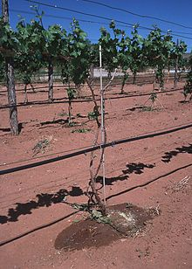
Drip irrigation system in New Mexico
Water conservation programs involved in social solutions are typically initiated at the local level, by either municipal water utilities or regional governments. Common strategies include public out reach campaigns^{[4]}, or restrictions on outdoor water use such as lawn watering and car washing.^{[5]} Cities in dry climates often require or encourage the installation of xeriscaping or natural landscaping in new homes to reduce outdoor water usage.^{[6]}
One fundamental conservation goal is universal metering. The prevalence of residential water metering varies significantly worldwide. Recent studies have estimated that water supplies are metered in less than 30% of UK households,^{[7]} and about 61% of urban Canadian homes (as of 2001).^{[8]} Although individual water meters have often been considered impractical in homes with private wells or in multifamily buildings, the U.S. Environmental Protection Agency estimates that metering alone can reduce consumption by 20 to 40 percent.^{[9]} In addition to raising consumer awareness of their water use, metering is also an important way to identify and localize water leakage. Water metering would benefit society in the long run it is proven that water metering increases the efficiency of the entire water system, as well as help unnecessary expenses for individuals for years to come. One would be unable to waste water unless they are willing to pay the extra charges, this way the water department would be able to monitor water usage by public, domestic and manufacturing services.
Some researchers have suggested that water conservation efforts should be primarily directed at farmers, in light of the fact that crop irrigation accounts for 70% of the world's fresh water use.^{[10]} The agricultural sector of most countries is important both economically and politically, and water subsidies are common. Conservation advocates have urged removal of all subsidies to force farmers to grow more water-efficient crops and adopt less wasteful irrigation techniques.
New technology poses a few new options for consumers, features such and full flush and half flush when using a toilet are trying to make a difference in water consumption and waste. Also available in our modern world is shower heads that help reduce wasting water, old shower heads are said to use 5-10 gallons per minute. All new fixtures available are said to use 2.5 gallons per minute and offer equal water coverage.

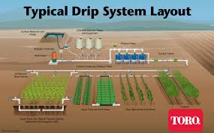

Household applications
The Home Water Works website contains useful information on household water conservation.^{[11]} Contrary to popular view, experts suggest the most efficient way is replacing toilets and retrofitting washers.^{[12]}

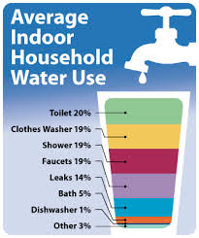

Water-saving technology for the home includes:
- Low-flow shower heads sometimes called energy-efficient shower heads as they also use less energy
- Low-flush toilets and composting toilets. These have a dramatic impact in the developed world, as conventional Western toilets use large volumes of water
- Raw water flushing where toilets use sea water or non-purified water
- Wastewater reuse or recycling systems, allowing:
  - Reuse of graywater for flushing toilets or watering gardens
  - Recycling of wastewater through purification at a water treatment plant. See also Wastewater - Reuse
- Rainwater harvesting
- High-efficiency clothes washers.
- Swimming pool covers that reduce evaporation and can warm pool water to reduce water, energy and chemical costs.

Commercial applications
Many water-saving devices (such as low-flush toilets) that are useful in homes can also be useful for business water saving. Other water-saving technology for businesses includes:
- Waterless urinals
- Waterless car washes
- Infrared or foot-operated taps, which can save water by using short bursts of water for rinsing in a kitchen or bathroom
- X-ray film processor re-circulation system.
- Water-saving steam sterilizers, for use in hospitals and health care facilities
- Rain water harvesting
- Water to Water heat exchangers.

Agricultural applications[edit]
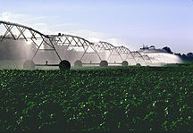
Overhead irrigation, center pivot irrigation design
For crop irrigation, optimal water efficiency means minimizing losses due to evaporation, runoff or subsurface drainage while maximizing production. An evaporation pan in combination with specific crop correction factors can be used to determine how much water is needed to satisfy plant requirements. Flood irrigation, the oldest and most common type, is often very uneven in distribution, as parts of a field may receive excess water in order to deliver sufficient quantities to other parts. Overhead irrigation, using center-pivot or lateral-moving sprinklers, has the potential for a much more equal and controlled distribution pattern. Drip irrigation is the most expensive and least-used type, but offers the ability to deliver water to plant roots with minimal losses. However, drip irrigation is increasingly affordable, especially for the home gardener and in light of rising water rates. There are also cheap effective methods similar to drip irrigation such as the use of soaking hoses that can even be submerged in the growing medium to eliminate evaporation.
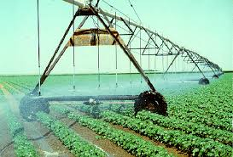

The 2011 UNEP Green Economy Report notes that "[i]mproved soil organic matter from the use of green manures, mulching, and recycling of crop residues and animal manure increases the water holding capacity of soils and their ability to absorb water during torrential rains," ^{[13]} which is a way to optimize the use of rainfall and irrigation during dry periods in the season.

Minimum water network target and design
The cost effective minimum water network is a holistic framework/guide for water conservation that helps in determining the minimum amount of freshwater and wastewater target for an industrial or urban system based on the water management hierarchy i.e. it considers all conceivable methods to save water. The technique ensure that the designer desired payback period is satisfied using Systematic Hierarchical Approach for Resilient Process Screening (SHARPS) technique.

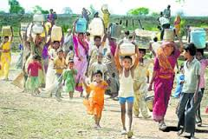

Visit page | View image

Importance of Water Conservation
Fresh, clean water is a limited resource. While most of the planet is covered in water, it is salt water that can only be consumed by humans and other species after undergoing desalination, which is an expensive process. Occurrences such as droughts further limit access to clean and fresh water, meaning people need to take steps to reduce water use and save as much water as possible. In some areas of the world, access to water is limited due to contamination. People who have access to fresh water can take steps to limit their use of water to avoid waste.

The Why and How of Water Conservation

People should do their best to conserve water for three reasons. The less water used or wasted by people, the less clean water will become contaminated. In some cases, using excess amounts of water puts strain on septic and sewage systems, leading to contamination of groundwater, as untreated, dirty water seeps from the sewage system into the ground.

Water conservation reduces energy use and can even save households money. Most families pay to use water in their cities or regions. The less water a household uses, the less they have to pay each period. Appliances that use water, such as washing machines and dishwashers, also use a considerable amount of energy.

Conserving water now allows cities and regions to plan for more efficient use of the water resources in the future. If most of an area's clean water is wasted, there will not be water for future generations to use, meaning the city will need to come up with new ways to produce clean, fresh water, which will ultimately be at the taxpayers' expense.

Why Water Efficiency - Information and tips on saving water from the Environmental Protection Agency.
Water Conservation - The importance of water conservation to protect spots such as Mono Lake, in California.
Future Water - Information on Future Water, a program from the National Environmental Services Center designed to educate people about the importance of water conservation.
Water Quality (PDF) - Pamphlet from Purdue University on the importance of saving water at home.
Conserving Water (PDF) - Kid-friendly brochure from Texas A&M University on saving water.
Tips for Saving Water
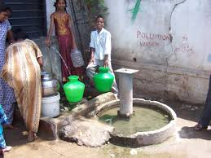
People can save water by making smart choices at home. They should only use appliances that rely on water when those appliances are full. For example, a family should wait to use the dishwasher until it is completely loaded with dishes. Surprisingly, using the dishwasher uses less water than washing by hand. Other ways to conserve water include taking shorter showers and only watering gardens and lawns when necessary.

Conserving Water At Home - Quick and simple tips for saving water at home from the University of Maine.

Educational Resources for Water Conservation

Teachers who wish to teach students about the importance of water conservation can find plenty of lesson plans and activities online. The lessons teach students the importance of saving water and provide tips for saving water at home or school.

Water Conservation Lesson Plan - Lesson plan for middle school students on saving water at home.

An Introduction to Rainwater Harvesting
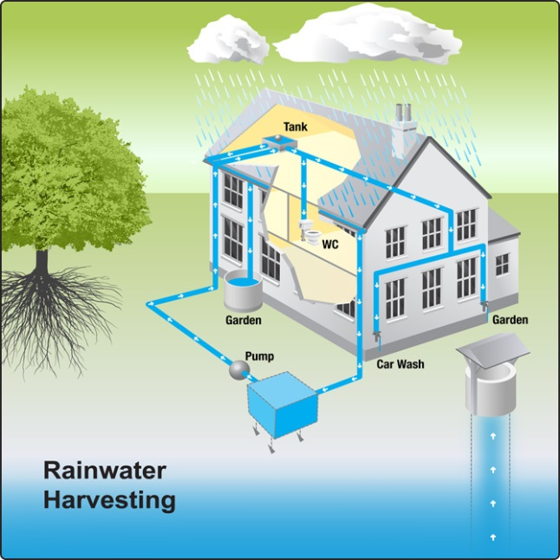

General Description
Rainwater harvesting is a technology used for collecting and storing rainwater from rooftops, the land surface or rock catchments using simple techniques such as jars and pots as well as more complex techniques such as underground check dams. Africa arise from practices employed by ancient civilizations within these regions and still serve as a major source of drinking water supply in rural areas. Commonly used systems are constructed of three principal components; namely, the catchment area, the collection device, and the conveyance system.

  - Catchment Areas

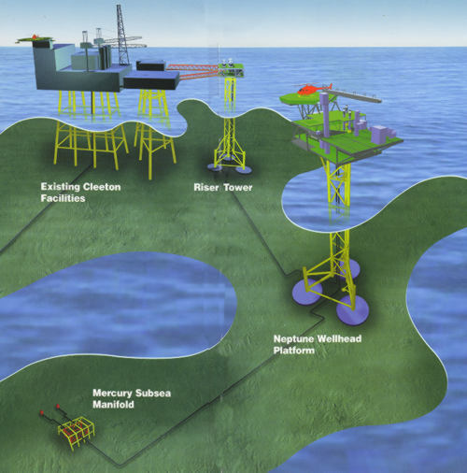
Rooftop catchments: In the most basic form of this technology, rainwater is collected in simple vessels at the edge of the roof. Variations on this basic approach include collection of rainwater in gutters which drain to the collection vessel through down-pipes constructed for this purpose, and/or the diversion of rainwater from the gutters to containers for settling particulates before being conveyed to the storage container for the domestic use. As the rooftop is the main catchment area, the amount and quality of rainwater collected depends on the area and type of roofing material. Reasonably pure rainwater can be collected from roofs constructed with galvanized corrugated iron, aluminium or asbestos cement sheets, tiles and slates, although thatched roofs tied with bamboo gutters and laid in proper slopes can produce almost the same amount of runoff less expensively (Gould, 1992). However, the bamboo roofs are least suitable because of possible health hazards.
Land surface catchments: Rainwater harvesting using ground or land surface catchment areas is less complex way of collecting rainwater. It involves improving runoff capacity of the land surface through various techniques including collection of runoff with drain pipes and storage of collected water. Compared to rooftop catchment techniques, ground catchment techniques provide more opportunity for collecting water from a larger surface area. There is a possibility of high rates of water loss due to infiltration into the ground, and, because of the often marginal quality of the water collected, this technique is mainly suitable for storing water for agricultural purposes. Various techniques available for increasing the runoff within ground catchment areas involve
Clearing or altering vegetation cover: Clearing vegetation from the ground can increase surface runoff but also can induce more soil erosion. Use of dense vegetation cover such as grass is usually suggested as it helps to both maintain an high rate of runoff and minimize soil erosion.
Increasing slope: Steeper slopes can allow rapid runoff of rainfall to the collector. However, the rate of runoff has to be controlled to minimise soil erosion from the catchment field. Use of plastic sheets, asphalt or tiles along with slope can further increase efficiency by reducing both evaporative losses and soil erosion.
Soil compaction by physical means: This involves smoothing and compacting of soil surface using equipment such as graders and rollers. To increase the surface runoff and minimize soil erosion rates, conservation bench terraces are constructed along a slope perpendicular to runoff flow. The bench terraces are separated by the sloping collectors and provision is made for distributing the runoff evenly across the field strips as sheet flow.
Soil compaction by chemical treatments: In addition to clearing, shaping and compacting a catchment area, chemical applications with such soil treatments as sodium can significantly reduce the soil permeability. Use of aqueous solutions of a silicone-water repellent is another technique for enhancing soil compaction technologies.

  - Collection Devices
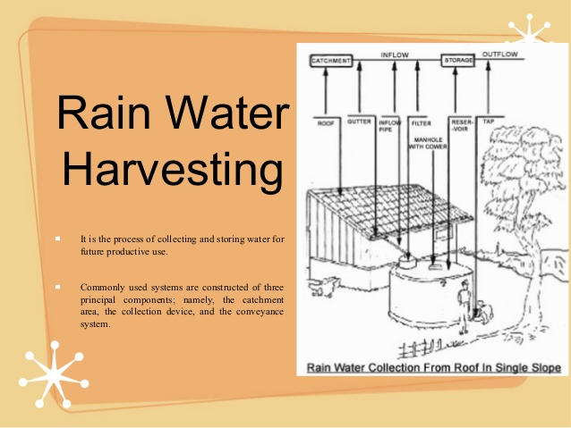
Storage tanks: Storage tanks for collecting rainwater harvested using guttering may be either above or below the ground. Precautions required in the use of storage tanks include provision of an adequate enclosure to minimise contamination from human, animal or other environmental contaminants, and a tight cover to prevent algal growth and the breeding of mosquitos. Open containers are not recommended for collecting water for drinking purposes. Various types of rainwater storage facilities can be found in practice. Among them are cylindrical ferrocement tanks and mortar jars. The ferrocement tank consists of a lightly reinforced concrete base on which is erected a circular vertical cylinder with a 10 mm steel base. This cylinder is further wrapped in two layers of light wire mesh to form the frame of the tank. Mortar jars are large jar shaped vessels constructed from wire reinforced mortar. The storage capacity needed should be calculated to take into consideration the length of any dry spells, the amount of rainfall, and the per capita water consumption rate. In most of the Asian countries, the winter months are dry, sometimes for weeks on end, and the annual average rainfall can occur within just a few days. In such circumstances, the storage capacity should be large enough to cover the demands of two to three weeks. For example, a three person household should have a minimum capacity of 3 (Persons) x 90 (l) x 20 (days) = 5 400 l.
Rainfall water containers: As an alternative to storage tanks, battery tanks (i.e., interconnected tanks) made of pottery, ferrocement, or polyethylene may be suitable. The polyethylene tanks are compact but have a large storage capacity (ca. 1 000 to 2 000 l), are easy to clean and have many openings which can be fitted with fittings for connecting pipes. In Asia, jars made of earthen materials or ferrocement tanks are commonly used. During the 1980s, the use of rainwater catchment technologies, especially roof catchment systems, expanded rapidly in a number of regions, including Thailand where more than ten million 2 m3 ferrocement rainwater jars were built and many tens of thousands of larger ferrocement tanks were constructed between 1991 and 1993. Early problems with the jar design were quickly addressed by including a metal cover using readily available, standard brass fixtures. The immense success of the jar programme springs from the fact that the technology met a real need, was affordable, and invited community participation. The programme also captured the imagination and support of not only the citizens, but also of government at both local and national levels as well as community based organizations, small-scale enterprises and donor agencies. The introduction and rapid promotion of Bamboo reinforced tanks, however, was less successful because the bamboo was attacked by termites, bacteria and fungus. More than 50 000 tanks were built between 1986 and 1993 (mainly in Thailand and Indonesia) before a number started to fail, and, by the late 1980s, the bamboo reinforced tank design, which had promised to provide an excellent low-cost alternative to ferrocement tanks, had to be abandoned.
C) Conveyance Systems
Conveyance systems are required to transfer the rainwater collected on the rooftops to the storage tanks. This is usually accomplished by making connections to one or more down-pipes connected to the rooftop gutters. When selecting a conveyance system, consideration should be given to the fact that, when it first starts to rain, dirt and debris from the rooftop and gutters will be washed into the down-pipe. Thus, the relatively clean water will only be available some time later in the storm. There are several possible choices to selectively collect clean water for the storage tanks. The most common is the down-pipe flap. With this flap it is possible to direct the first flush of water flow through the down-pipe, while later rainfall is diverted into a storage tank. When it starts to rain, the flap is left in the closed position, directing water to the down-pipe, and, later, opened when relatively clean water can be collected. A great disadvantage of using this type of conveyance control system is the necessity to observe the runoff quality and manually operate the flap. An alternative approach would be to automate the opening of the flap as described below.

A funnel-shaped insert is integrated into the down-pipe system. Because the upper edge of the funnel is not in direct contact with the sides of the down-pipe, and a small gap exists between the down-pipe walls and the funnel, water is free to flow both around the funnel and through the funnel. When it first starts to rain, the volume of water passing down the pipe is small, and the *dirty* water runs down the walls of the pipe, around the funnel and is discharged to the ground as is normally the case with rainwater guttering. However, as the rainfall continues, the volume of water increases and *clean* water fills the down-pipe. At this higher volume, the funnel collects the clean water and redirects it to a storage tank. The pipes used for the collection of rainwater, wherever possible, should be made of plastic, PVC or other inert substance, as the pH of rainwater can be low (acidic) and could cause corrosion, and mobilization of metals, in metal pipes.

In order to safely fill a rainwater storage tank, it is necessary to make sure that excess water can overflow, and that blockages in the pipes or dirt in the water do not cause damage or contamination of the water supply. The design of the funnel system, with the drain-pipe being larger than the rainwater tank feed-pipe, helps to ensure that the water supply is protected by allowing excess water to bypass the storage tank. A modification of this design is shown in Figure 5, which illustrates a simple overflow/bypass system. In this system, it also is possible to fill the tank from a municipal drinking water source, so that even during a prolonged drought the tank can be kept full. Care should be taken, however, to ensure that rainwater does not enter the drinking water distribution system.

Cultural Acceptability
Rainwater harvesting is an accepted freshwater augmentation technology in Asia. While the bacteriological quality of rainwater collected from ground catchments is poor, that from properly maintained rooftop catchment systems, equipped with storage tanks having good covers and taps, is generally suitable for drinking, and frequently meets WHO drinking water standards. Notwithstanding, such water generally is of higher quality than most traditional, and many of improved, water sources found in the developing world. Contrary to popular beliefs, rather than becoming stale with extended storage, rainwater quality often improves as bacteria and pathogens gradually die off (Wirojanagud et al., 1989). Rooftop catchment, rainwater storage tanks can provide good quality water, clean enough for drinking, as long as the rooftop is clean, impervious, and made from non-toxic materials (lead paints and asbestos roofing materials should be avoided), and located away from over-hanging trees since birds and animals in the trees may defecate on the roof.
Advantages
Rainwater harvesting technologies are simple to install and operate. Local people can be easily trained to implement such technologies, and construction materials are also readily available. Rainwater harvesting is convenient in the sense that it provides water at the point of consumption, and family members have full control of their own systems, which greatly reduces operation and maintenance problems. Running costs, also, are almost negligible. Water collected from roof catchments usually is of acceptable quality for domestic purposes. As it is collected using existing structures not specially constructed for the purpose, rainwater harvesting has few negative environmental impacts compared to other water supply project technologies. Although regional or other local factors can modify the local climatic conditions, rainwater can be a continuous source of water supply for both the rural and poor. Depending upon household capacity and needs, both the water collection and storage capacity may be increased as needed within the available catchment area.
Disadvantages
Disadvantages of rainwater harvesting technologies are mainly due to the limited supply and uncertainty of rainfall. Adoption of this technology requires a *bottom up* approach rather than the more usual *top down* approach employed in other water resources development projects. This may make rainwater harvesting less attractive to some governmental agencies tasked with providing water supplies in developing countries, but the mobilization of local government and NGO resources can serve the same basic role in the development of rainwater-based schemes as water resources development agencies in the larger, more traditional public water supply schemes.
Suitability
The augmentation of municipal water supplies with harvested rainwater is suited to both urban and rural areas. The construction of cement jars or provision of gutters does not require very highly skilled manpower.
Development Costs
The capital cost of rainwater harvesting systems is highly dependent on the type of catchment, conveyance and storage tank materials used. However, the cost of harvested rainwater in Asia, which varies from $0.17 to $0.37 per cubic metre of water storage, is relatively low compared to many countries in Africa (Lee and Vissher, 1990).
Compared to deep and shallow tubewells, rainwater collection systems are more cost effective, especially if the initial investment does not include the cost of roofing materials. The initial per unit cost of rainwater storage tanks (jars) in Northeast Thailand is estimated to be about $1/l, and each tank can last for more than ten years. The reported operation and maintenance costs are negligible.

Effectivness of Technology
The feasibility of rainwater harvesting in a particular locality is highly dependent upon the amount and intensity of rainfall. Other variables, such as catchment area and type of catchment surface, usually can be adjusted according to household needs. As rainfall is usually unevenly distributed throughout the year, rainwater collection methods can serve as only supplementary sources of household water. The viability of rainwater harvesting systems is also a function of: the quantity and quality of water available from other sources; household size and per capita water requirements; and budget available. The decision maker has to balance the total cost of the project against the available budget, including the economic benefit of conserving water supplied from other sources. Likewise, the cost of physical and environmental degradation associated with the development of available alternative sources should also be calculated and added to the economic analysis.
Assuming that rainwater harvesting has been determined to be feasible, two kinds of techniques--statistical and graphical methods--have been developed to aid in determining the size of the storage tanks. These methods are applicable for rooftop catchment systems only, and detail guidelines for design of these storage tanks can be found in Gould (1991) and Pacey and Cullis (1986, 1989).

Accounts of serious illness linked to rainwater supplies are few, suggesting that rainwater harvesting technologies are effective sources of water supply for many household purposes. It would appear that the potential for slight contamination of roof runoff from occasional bird droppings does not represent a major health risk; nevertheless, placing taps at least 10 cm above the base of the rainwater storage tanks allows any debris entering the tank to settle on the bottom, where it will not affect the quality of the stored water, provided it remains undisturbed. Ideally, storage tanks should cleaned annually, and sieves should fitted to the gutters and down-pipes to further minimize particulate contamination. A coarse sieve should be fitted in the gutter where the down-pipe is located. Such sieves are available made of plastic coated steel-wire or plastic, and may be wedged on top and/or inside gutter and near the down-pipe. It is also possible to fit a fine sieve within the down-pipe itself, but this must be removable for cleaning. A fine filter should also be fitted over the outlet of the down-pipe as the coarser sieves situated higher in the system may pass small particulates such as leaf fragments, etc. A simple and very inexpensive method is to use a small, fabric sack, which may be secured over the feed-pipe where it enters the storage tank.

If rainwater is used to supply household appliances such as the washing machine, even the tiniest particles of dirt may cause damage to the machine and the washing.
Further Development of Technology
Rainwater harvesting appears to be one of the most promising alternatives for supplying freshwater in the face of increasing water scarcity and escalating demand. The pressures on rural water supplies, greater environmental impacts associated with new projects, and increased opposition from NGOs to the development of new surface water sources, as well as deteriorating water quality in surface reservoirs already constructed, constrain the ability of communities to meet the demand for freshwater from traditional sources, and present an opportunity for augmentation of water supplies using this technology.
WATERSHED MANAGEMENT
Watershed is defined as a geohydrological unit draining to a common point by a system of drains. All lands on earth are part of one watershed or other. Watershed is thus the land and water area, which contributes runoff to a common point.
A watershed is an area of land and water bounded by a drainage divide within which the surface runoff collects and flows out of the watershed through a single outlet into a lager river ( or ) lake.
Objectives of watershed management
The different objectives of watershed management programmes are:
1. To control damaging runoff and degradation and thereby conservation of soil and water.
2. To manage and utilize the runoff water for useful purpose.
3. To protect, conserve and improve the land of watershed for more efficient and
sustained production.
4. To protect and enhance the water resource originating in the watershed.
diversion Factors affecting watershed management
a) Watershed characters
i) Size and shape
ii) Topography
iii) Soils
iv) Relief
b) Climatic characteristic
i. Precipitation
ii. Amount and intensity of rainfall
c) Water resource and their capabilities.
Watershed management practices
1. Interms of purpose
1. To increase infiltration
2. To increase water holding capacity
3. To prevent soil erosion
2. Method and accomplishment
. Watershed Protection Management Measure
Develop a watershed protection program to:
1. Avoid conversion, to the extent practicable, of areas that are particularly susceptible to erosion and sediment loss;
2. Preserve areas that provide important water quality benefits and/or are necessary to maintain riparian and aquatic biota; and
3. Site development, including roads, highways, and bridges, to protect to the extent practicable the natural integrity of waterbodies and natural drainage systems.
1. Applicability
This management measure is intended to be applied by States to new development or redevelopment including construction of new and relocated roads, highways, and bridges that generate nonpoint source pollutants. Under the Coastal Zone Act Reauthorization Amendments of 1990, States are subject to a number of requirements as they develop coastal nonpoint source programs in conformity with this management measure and will have flexibility in doing so. The application of management measures by States is described more fully in Coastal Nonpoint Pollution Control Program: Program Development and Approval Guidance, published by the U.S. Environmental Protection Agency (EPA) and the National Oceanic and Atmospheric Administration (NOAA) of the U.S. Department of Commerce.

2. Description
The purpose of this management measure is to reduce the generation of nonpoint source pollutants and to mitigate the impacts of urban runoff and associated pollutants that result from new development or redevelopment, including the construction of new and relocated roads, highways, and bridges. The measure is intended to provide general goals for States and local governments to use in developing comprehensive programs for guiding future development and land use activities in a manner that will prevent and mitigate the effects of nonpoint source pollution.
3. Management Measure Selection and Effectiveness Information
This measure was selected for the following reasons:
1. Watershed protection is a technique to provide long-term water quality benefits, and many States and local communities already use this practice. Numerous State and local governments have already legislated and implemented detailed watershed planning controls that are consistent with this management measure. For example, Oregon, New Jersey, Delaware, and Florida have passed legislation that requires county and municipal governments to adopt comprehensive plans, including requirements to direct future development away from sensitive areas. Several municipalities and regions, in addition to those in these States, have adopted land use and growth controls, including Amherst, Massachusetts, the Cape Cod region, Norwood, Massachusetts, and Narragansett, Rhode Island.
2. Setting general water quality objectives oriented toward protection of environmentally sensitive areas and areas that provide water quality benefits allows States flexibility in the pursuit of widely differing water quality priorities and reduces potential conflicts that may arise due to existing State or local program goals and requirements. Although public comments on the May 1991 draft guidance suggested that much more specific criteria should be required, such as minimum setbacks from waterbodies, prohibitions on development on slopes in excess of 45 degrees, and bans on development in floodplains, such prescriptive measures are deemed unreasonable given the need for State and local determination of priorities and program direction.
CASE STUDY 1 - RHODE RIVER ESTUARY, CHESAPEAKE BAY, MARYLAND
An evaluation of the impact of the Maryland Critical Area Act on nonpoint source pollution (nutrients and sediment) in surface runoff was completed by modeling three land use scenarios and determining the relative change in nonpoint loadings from the Rhode River Critical Area. Research findings suggest that the implementation of the Act will reduce nonpoint source nutrient and sediment loading by mandating agricultural and urban best management practices (BMPs) and limiting development in forested lands. Figure 4-4 illustrates the predicted nitrogen and phosphorus loadings from various land uses within the watershed under various development scenarios. These predictions are based on the assumption that no structural BMPs are in place.
5. Land or Development Rights Acquisition Practices and Cost Information
As discussed more fully at the beginning of this chapter and in Chapter 1, the following practices are described for illustrative purposes only. State programs need not require implementation of these practices. However, as a practical matter, EPA anticipates that the management measure set forth above generally will be implemented by applying one or more management practices appropriate to the source, location, and climate. The practices set forth below have been found by EPA to be representative of the types of practices that can be applied successfully to achieve the management measure described above.

An effective way to preserve land necessary for protecting the environmental integrity of an area is to acquire it outright or to limit development rights. The following practices can be used to protect beneficial uses.

ENVIRONMENTAL ETHICS

While the history of western philosophy is dominated by this kind anthropocentrism, it has come under considerable attack from many environmental ethicists. Such thinkers have claimed that ethics must be extended beyond humanity, and that moral standing should be accorded to the non-human natural world. Some have claimed that this extension should run to sentient animals, others to individual living organisms, and still others to holistic entities such as rivers, species and ecosystems. Under these ethics, we have obligations in respect of the environment because we actually owe things to the creatures or entities within the environment themselves. Determining whether our environmental obligations are founded on anthropocentric or non-anthropocentric reasoning will lead to different accounts of what those obligations are. This section examines the prominent accounts of moral standing within environmental ethics, together with the implications of each.
- Human Beings
Despite their human-centeredness, anthropocentric environmental ethics have nevertheless played a part in the extension of moral standing. This extension has not been to the non-human natural world though, but instead to human beings who do not yet exist. The granting of moral standing to future generations has been considered necessary because of the fact that many environmental problems, such as climate change and resource depletion, will affect future humans much more than they affect present ones. Moreover, it is evident that the actions and policies that we as contemporary humans undertake will have a great impact on the well-being of future individuals. In light of these facts, some philosophers have founded their environmental ethics on obligations to these future generations (Gewirth, 2001).
2. Radical Ecology

Not all philosophers writing on our obligations concerning the environment see the problem simply in terms of extending moral standing. Instead, many thinkers regard environmental concerns to have warranted an entirely new ideological perspective that has been termed, after its biological counterpart, “ecology”. While the ideas and beliefs within this “radical ecology” movement are diverse, they possess two common elements that separates them from the ethical extensionism outlined above. First of all, none see extending moral standing as sufficient to resolve the environmental crisis. They argue that a broader philosophical perspective is needed, requiring fundamental changes in both our attitude to and understanding of reality. This involves reexamining who we are as human beings and our place within the natural world. For radical ecologists, ethical extensionism is inadequate because it is stuck in the traditional ways of thinking that led to these environmental problems in the first place. In short, it is argued that ethical extensionism remains too human-centered, because it takes human beings as the paradigm examples of entities with moral standing and then extends outwards to those things considered sufficiently similar. Secondly, none of these radical ecologies confine themselves solely to the arena of ethics. Instead, radical ecologies also demand fundamental changes in society and its institutions. In other words, these ideologies have a distinctively political element, requiring us to confront the environmental crisis by changing the very way we live and function, both as a society and as individuals.
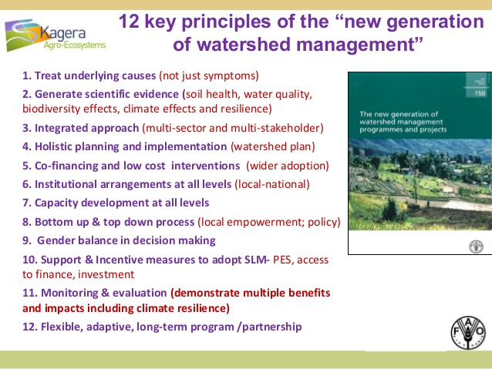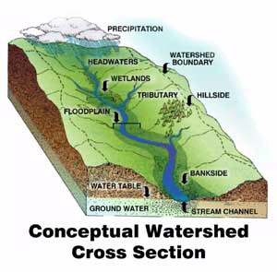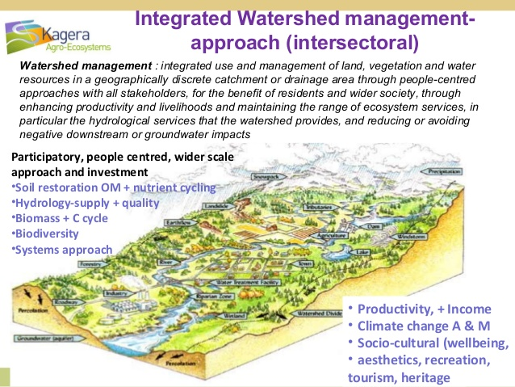

BIBLIOGRAPHY
ALL THE INFORMATION HAS BEEN SEARCHED FROM :
WWW.GOOGLE.COM
ENVIRONMENTAL EDUCATION BOOK
WWW.WIKIPEDIA.COM
TUTORIALSPOINT.

